# Manage Personal Information:

Step 1 : Click on your profile Icon and view profile

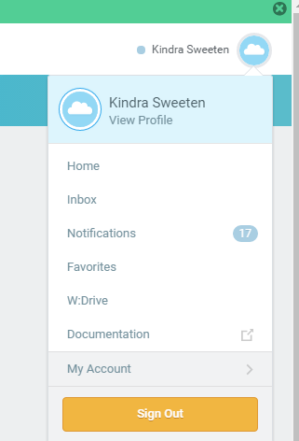

# Manage Career Information:

Step 1 : From your profile click on Career

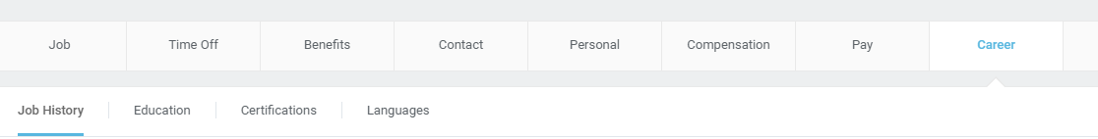

Step 2 : Click Edit within each section to change existing information or the add button to add new information.

